E-DONOR

# ABSTRACT

With the revolution of communications now-a-days people needs

technologies developments in all domains, especially in health domains. This project acts as an important role in saving life and provides all of the information available for the blood group that is always demand on a ongoing basis. This application is characterized by use and contact with other donors and needy for different blood groups. This application can installed on smart devices. Through this application any person who is interested in donating the blood can register by giving formal details such as name, city, group, contact number. If any person wants to make request for blood he can take the help from this application. The project has been planned to be having the view of distributed architecture, with centralized storage of database. By using this application we can easily find the nearest blood donor as quickly as possible.

# OBJECTIVE:

To create awareness and motivate people for Blood Donation…..To help anyone, in case any requirement of blood. To end the concept of replacement donation by ensuring continuous supply of blood through voluntary BLOOD DONATION in Government blood banks.

# SYSTEM REQUIREMENTS :

* Operating system : Windows 7/8/9(32- or 64-bit)
* RAM : 3GB minimum,8GB recommended
* Available disk space :2GB minimum,4GB

recommended 500MB(IDE)+1.5GB(Android sdk)

* Screen resolution :1280x80 minimum

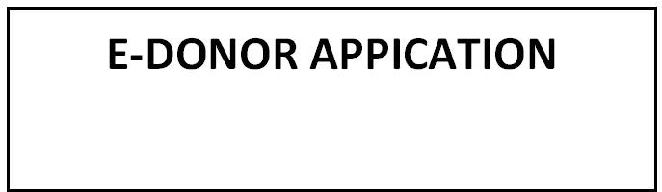

**NEED BLOOD**

**BE A DONOR**

**INFORMATION**

# FUNCTIONAL BLOCK DIAGRAM: